**Some useful graphics links and information**

prepared by Alison Cartwright, 03/13/2014

**Columbia's Energy Lab Map**

http://modi.mech.columbia.edu/resources/nycenergy/

**Nature video on Data visualization**

<http://www.youtube.com/watch?v=dvM4JPGsmVw>

**NY times graphics editor**

<http://simplystatistics.org/2012/06/01/interview-with-amanda-cox-graphics-editor-at-the-new/>

<http://kpq.github.io/chartsnthings/>

**Coursera free online videos on plotting**

http://blog.revolutionanalytics.com/2012/12/coursera-videos.html

**Course on Info graphics**

<http://www.skillshare.com/classes/design/Animated-Information-Graphics-using-data-and-motion-to-reveal-the-story/1100008111?via=profile>

* Figuring out the story and whats important or interesting about the data
* Creating hierarchy of interesting elements and an organizational scheme
* Writing a script
* Creating the final storyboard

**Another infographics website**

<http://infosthetics.com/>

**R interactive graphics with SVG package**

<http://timelyportfolio.github.io/gridSVG_intro/>

http://flowingdata.com/

**ggplot2 tutorial definitions**



**aesthetics** – all of the attributes that can be perceived on the graph. ie. horizontal and vertical position,point size, point color

**faceting** – creates tables of graphics by splitting the data into subsets and displaying the same graph for each subset in an arrangement that facilitates comparison

**scaling** – converts values in a data frame that have no real meaning (they are just values) to physical units that the computer can display, ie. Pixels and colors

**geoms** – geometric objects; determine the type of plot:

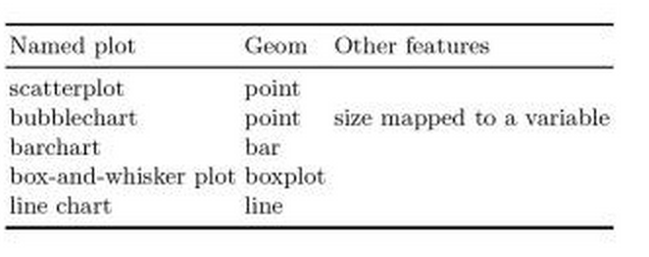

**Reference**

Wickham, H. (2009). *ggplot2: elegant graphics for data analysis*. Springer.